Joseph Silva Jr.

SNHU

CS 405: 2-2 M2 SQL Injection

11/07/2021

**Original Code Debug Results**

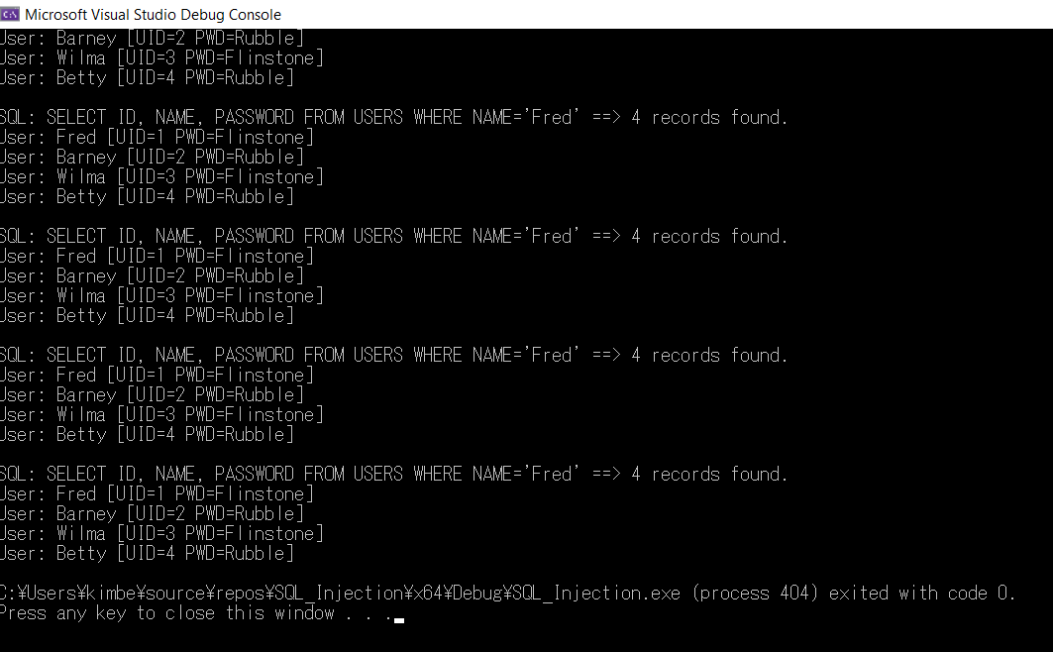

**Updated Code Debug Results**

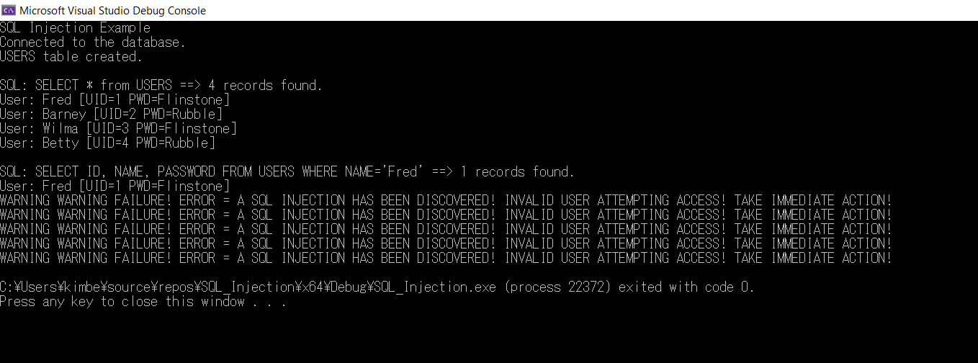

**Summary:**

For my code, I included the regular express library or <regex> which allowed search for sequence of characters and patterns. I then used regex to detect SQL Injections, which are one of the common ways of web hacking. If the system found a set of coding attempting to talk to the database that matched a pattern of a SQL Injection, a warning message of an SQL Injection has been discovered and an invalid user attempting to gain access. This message causes a failure / error message to block access to the entrance of the database.